LAB 4

1. Counting Elements

PROGRAM:

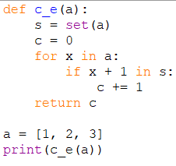

OUTPUT:

1. Perform String Shifts

PROGRAM:

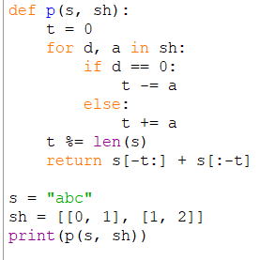

OUTPUT:

1. Leftmost Column with at Least a One

PROGRAM:

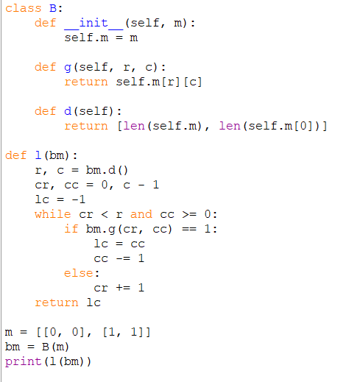

OUTPUT:

1. First Unique Number

PROGRAM:

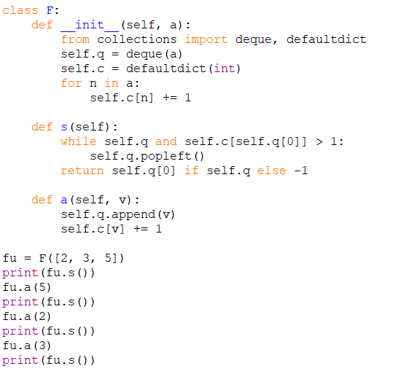

OUTPUT:



1. Check If a String Is a Valid Sequence from Root to Leaves Path in a Binary Tree

PROGRAM:

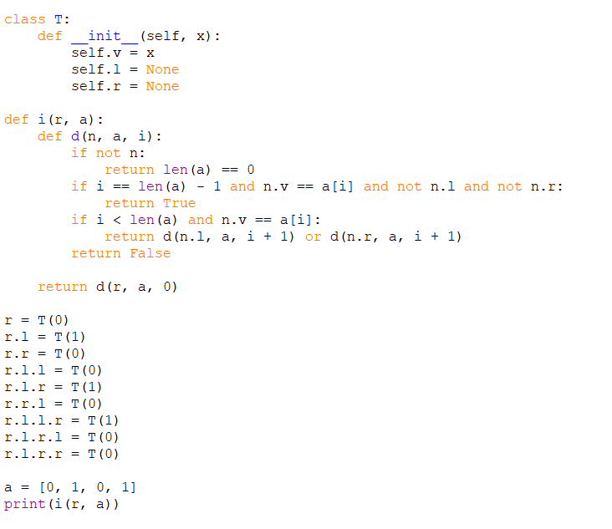

OUTPUT:

1. Kids With the Greatest Number of Candies

PROGRAM:

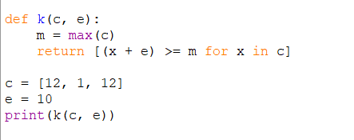

OUTPUT:

1. Max Difference You Can Get From Changing an Integer

PROGRAM:

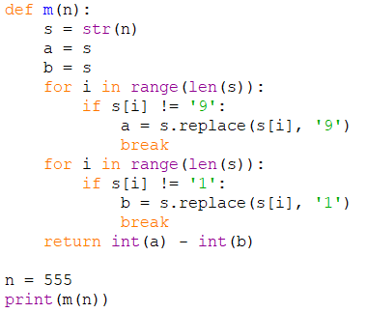

OUTPUT:

1. Check If a String Can Break Another String

PROGRAM:

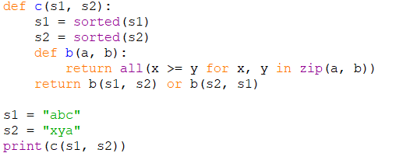

OUTPUT:

1. Number of Ways to Wear Different Hats to Each Other

PROGRAM:

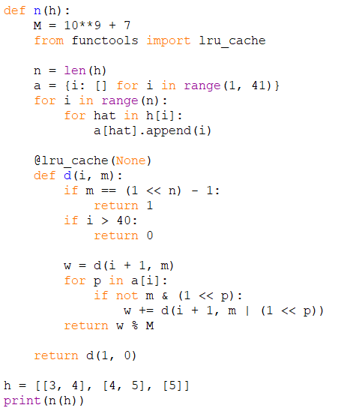

OUTPUT:

1. Destination City

PROGRAM:

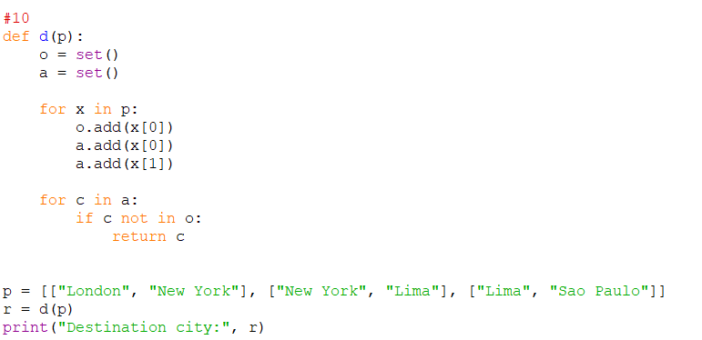

OUTPUT: